**A) Leer y unir con el comando adecuado. (Comandos que usamos al enviar e-mails)**

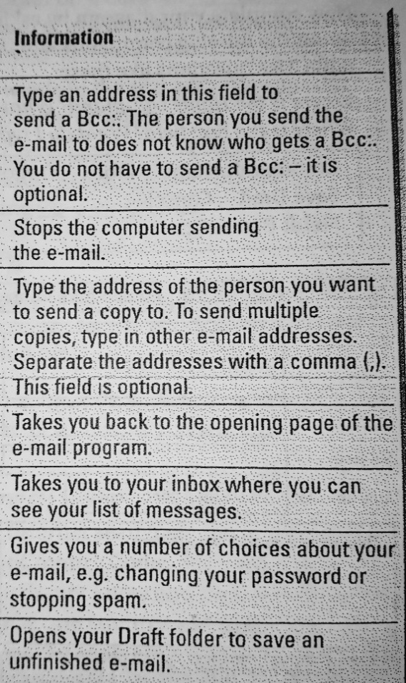

CANCEL

Cc: (carbon copy)

INBOX

SAVE DRAFT

HOME

Bcc: (blind carbon copy)

OPTIONS

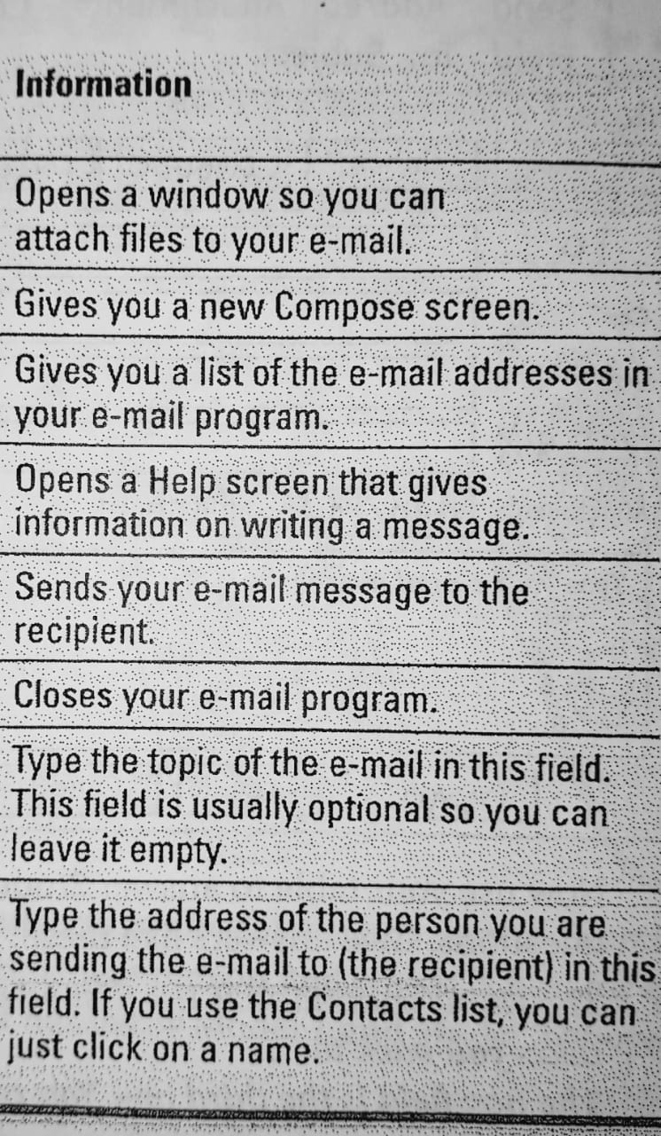

ADD/EDIT ATTACHMENTS

SING OUT

COMPOSE

CONTACTS

HELP

SEND

SUBJECT

TO: